CECS 303 – Networks and Network Security

Lab 4 - Wireshark

Capture TelNet credentials 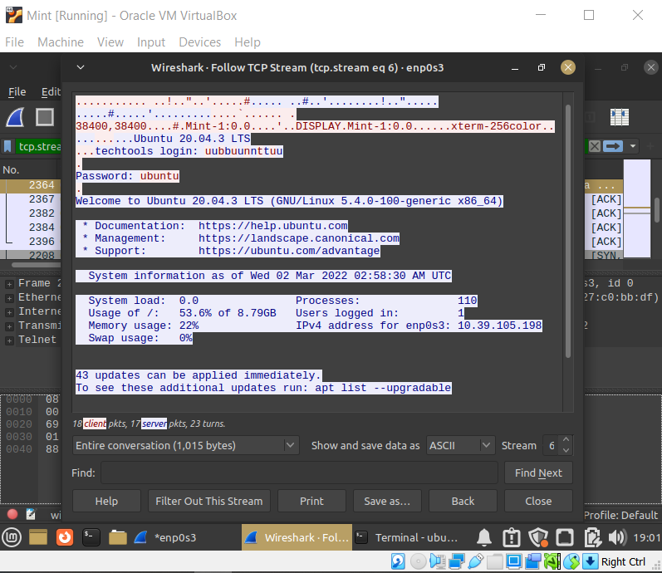



Capture SSH Session

Sudo iptables -L

Question 2:

It can get the IP address of the host computer as well as what kind of OS and the version of that OS the host is running.